**CP Club 365Days Challenge**

**Date – 07/12/2022**

**Programming language – c++**

**Problem Statement**

**[https://practice.geeksforgeeks.org/problems/reverse-array-in-groups0255/1?page=1&difficulty[]=-1&category[]=Arrays&curated[]=1&sortBy=submissions](https://practice.geeksforgeeks.org/problems/reverse-array-in-groups0255/1?page=1&difficulty%5b%5d=-1&category%5b%5d=Arrays&curated%5b%5d=1&sortBy=submissions)**

**Your Code**:

// 0x51Day of 0x365Days challenge

// VEDANT BHARAD

// 07-12-2022

//{ Driver Code Starts

//Initial template for C++

#include <bits/stdc++.h>

using namespace std;

// } Driver Code Ends

//User function template for C++

class Solution{

public:

    //Function to reverse every sub-array group of size k.

    void reverseInGroups(vector<long long>& arr, int n, int k){

        int index=0;

        while (index<n-k)

        {

            int temp,i=index,j=index+k-1;

            while (i<j){

                temp=arr[i];

                arr[i]=arr[j];

                arr[j]=temp;

                i++;

                j--;

            }

            index=index+k;

        }

        k=n%k;

        int temp,i=index,j=index+k-1;

        while (i<j){

            temp=arr[i];

            arr[i]=arr[j];

            arr[j]=temp;

            i++;

            j--;

        }

    }

};

//{ Driver Code Starts.

int main() {

    int t;

    cin >> t;

    while(t--){

        int n;

        cin >> n;

        vector<long long> arr;

        int k;

        cin >> k;

        for(long long i = 0; i<n; i++){

            long long x;

            cin >> x;

            arr.push_back(x);

        }

        Solution ob;

        ob.reverseInGroups(arr, n, k);

        for(long long i = 0; i<n; i++){

            cout << arr[i] << " ";

        }

        cout << endl;

    }

    return 0;

}

// } Driver Code Ends

**Output (Screen Shot)**:

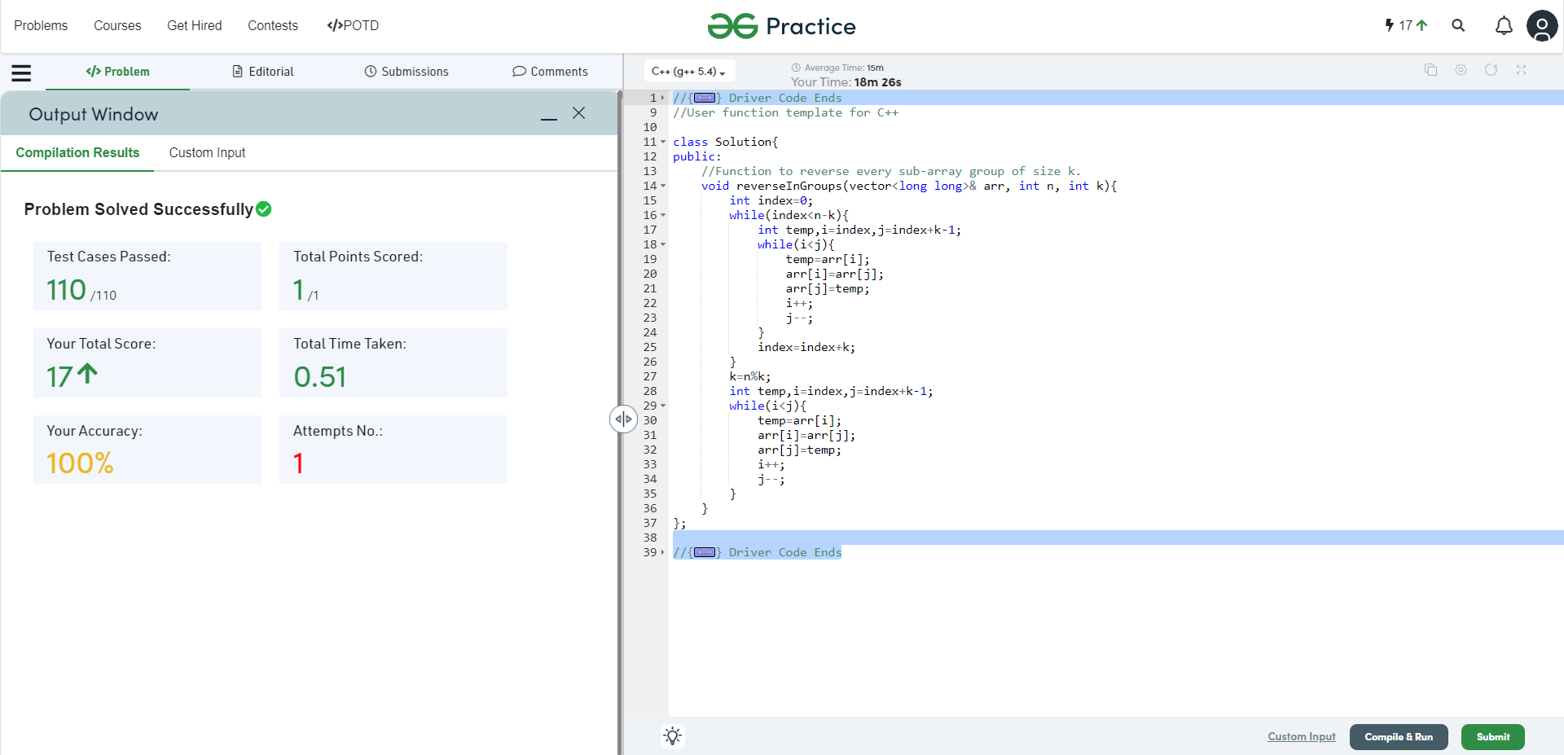

**Understanding about problem:**

1. In this task there are three inputs length of array , k value and array it self.
2. In this task I need to change index of array element as per given k value ,if k is 3 then I need to make part of array in k elements and reverse only that k element

Note: If you can't understand the problem, feel free to contact us and we'll help you. Please don't copy and paste from anywhere.

ALL THE BEST

Team CP Club